Domain and hosting:

# The domain name was purchased from the GoDaddy website.

chose the name appropriate for the purpose of the site for example watch center.

# search for the domain name

* **Purchase and checkout steps:**

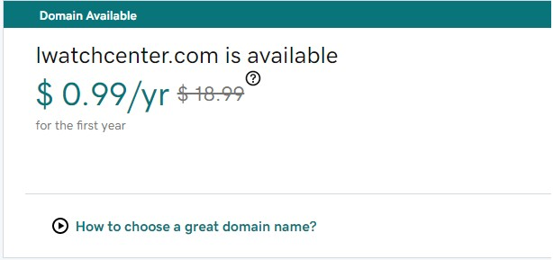

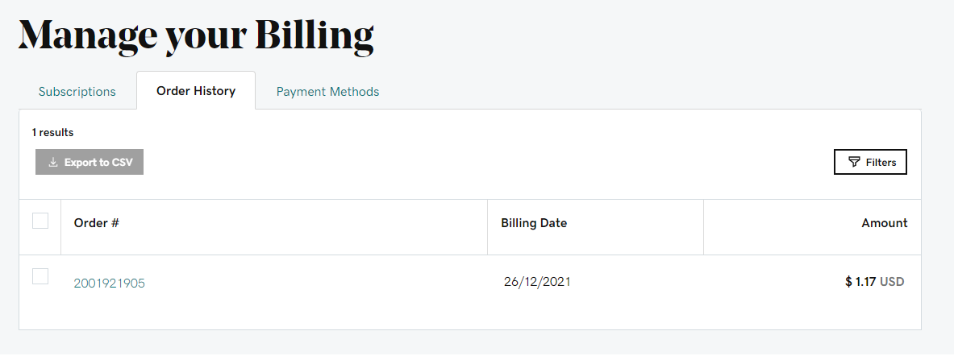

* **Checkout:**

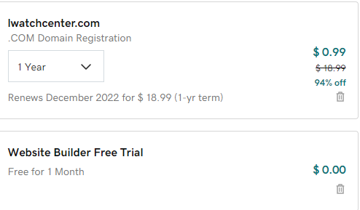

* + **The payment method.**

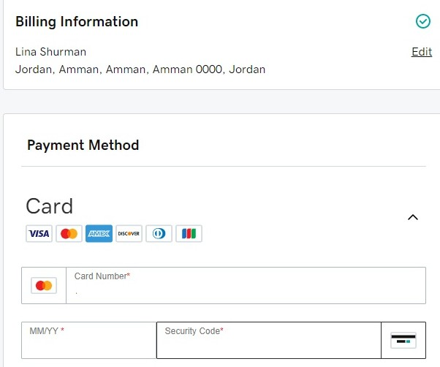

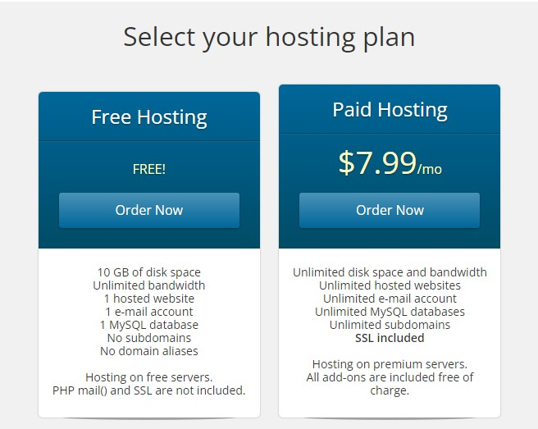

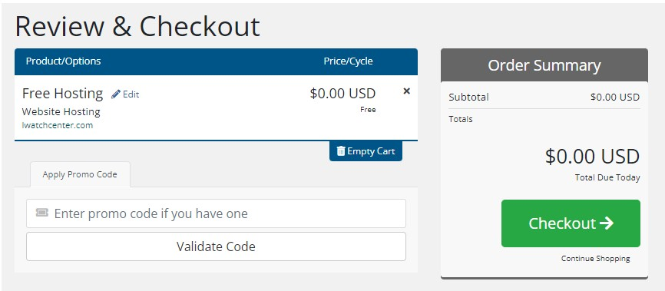

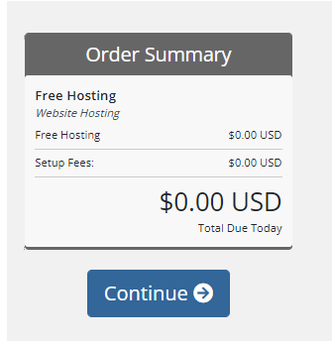

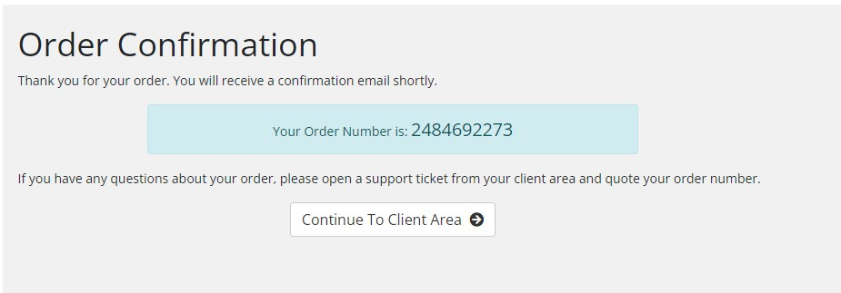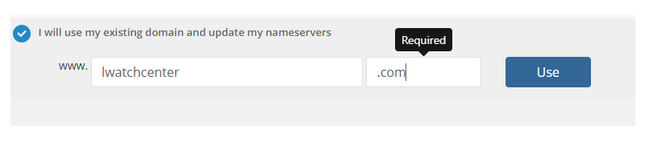

* **These are the hosting from free hosting:**

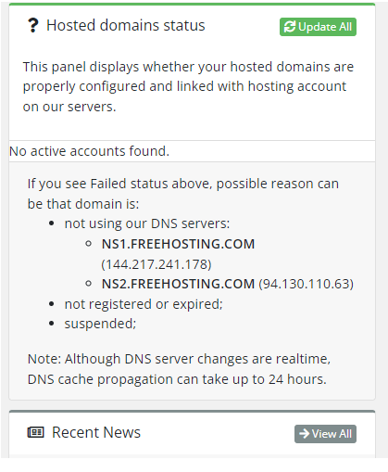

# Go to GoDaddy and changed the name server of my Domain name:

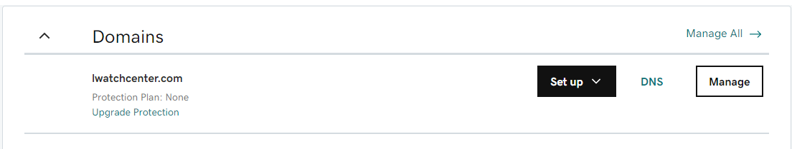

* **Here we have to put the two hosting that we buy from free hosting:**

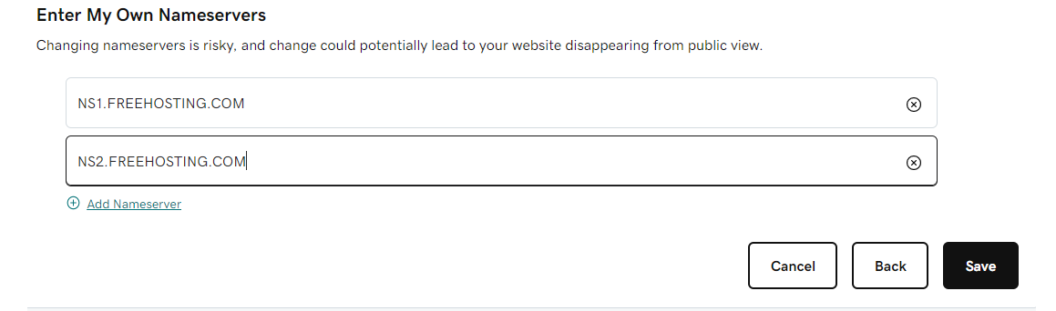

* **Confirmation the updated server’s name:**

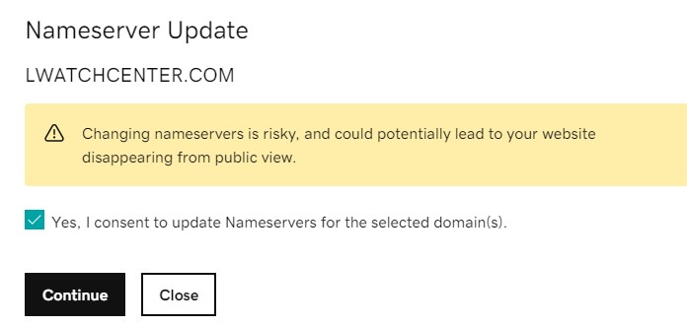

* **And the last step is to wait for the hosting to activate:**

